
PDST 2019-20 Season Parent Information

General Guide

1

Objectives

General PDST Info
- Practices and Pools
- PDST communication methods
- How to use your PDST account
  - Your PDST account
  - Member info
  - ACH setup (Invoice payment method)
  - Practice schedule
  - Swim Meet sign up
  - Volunteer job signup
  - Purchase PDST gears

Swim Meet and Meet Fee account for your swimmer
- Coaches and team staffs
- Parent Booster Club and its leadership team (the Board)
- Why Volunteering and how to volunteer
- Private lessons at PDST
- Team gears purchase
- Notes for practices and at pools
- Q/A period

2

Code of Conduct

We ask all PDST members (Coaches, staff members, swimmers, and parents) adhere to the code of conduct

US Swimming Code of Conduct
  - PDST Coach’s Code of Conduct
  - PDST Swimmer’s Code of Conduct
  - PDST Parent’s Code of Conduct
@ PDST website

3

PDST Communication Methods
- Dual communication methods
- Emails
PDSwimTeam@gmail.com (Team) – Most frequently used email account pdstservice@gmail.com (Reporting volunteer hours)
pdstleon@gmail.com (Training and meet)
- Website
  - www.PDSwimTeam.org
- What usually being communicated
- Practice schedule change
- Team news and related issues
- Meet info/entry/timeline/meet
- Efficiency in all aspects – Less spam, focus on the swimming
- If needed, but not efficient
  - Schedule an appointment
– Call/Text: 425-691-9165 (10am-5pm, Mon-Fri)
  - No deck interference at practice!!!

4

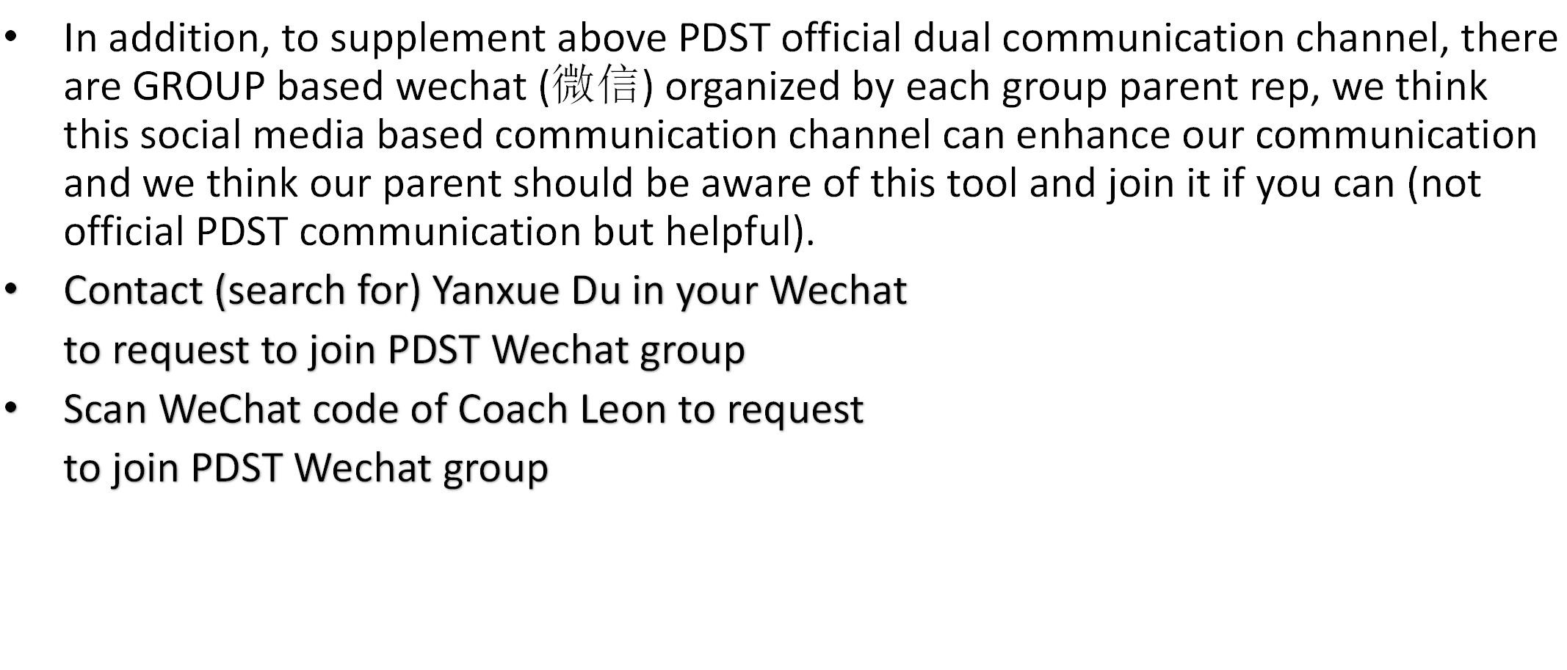PDST Group “WeChat” (微信) mobile App

Practice and Training General Guidelines

Safety is the priority
- Follow the rules & instructions
  - Pools
  - Team
- Respect to each other (parents, swimmers, coaches etc)
- Be on-time (ample time to find parking, locker room change etc)
  - Go to the pool with your swimmer and ensure you see the coach at the pool deck before leaving

Dry-land – bring in a pair of sneakers/cloths
- In-water practice
  - Be aware of other swimmers around you & water safety
  - Yield to other swimmers
  - No diving starts in all pools (unless instructed by a team coach)
- Ask if did not understand the instructions
  - Translation – be patient and it will get better

Feedback to the team with your concerns via an effective communication

6

Practice Pool Locations

We use 4 different pools for our practices (pool locations can be found at PDST website)
  - Mary Wayte Pool (MW)
8815 SE 40th St. Mercer Island, WA 98040; Phone: (206) 588-1117

  - Jewish Community Center Pool at Mercer Island (JCC)
3801 E. Mercer Way, Mercer Island, WA 98040; Phone: 206-232-7120

  - Bellevue Aquatic Center (BAC): 601 143rd Ave. NE. Bellevue, WA 98007. Phone: 425-452-4444

  - Hazen Pool @ Hazen High School: 1101 Hoquiam Ave NE, Renton, WA 98059. Phone: (425) 204-4230
- Sufficient practice times for all PDST groups
- Rotate pools among groups
  - Limited by pool time and duration

Swim Meets

    - Qualifying time standard
- Meet types
  - Challenge meet
  - Invitational meet
  - “Q” meet
  - Age Group Invitational
  - PNS Champ meet
  - Sectional Champ meet
  - Western Zone meet
  - Arena Pro Series
  - Junior National
  - National
      - None
      - Silver (age group)
      - Gold (age group)
      - PNS Champ (age group)
      - Sectional (age group)
      - Senior Sectional
      - Zone (age group)
      - Arena Pro Standard
      - Junior National standard
      - National standard

8

Swim Meets
- Meets are carefully selected, we do not go to every meet.
- Attend the meet when there is a meet for PDST.
- Relays at PNS Champ & Sectional meets are mandatory. Selection is based on swimmer’s time.

Silver

Gold

NW
Sectional
W. Zone

PDST AGI

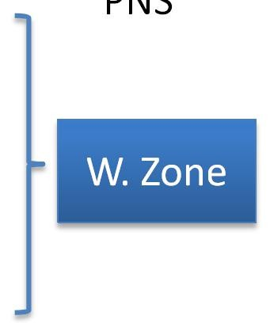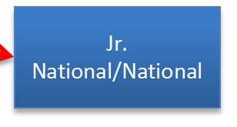

PNS

Qualifying Meet Qualify Time Required Meet

NW

Jr.
National/National

Meet Schedule is published at Team Website

Demo: https://www.teamunify.com/Home.jsp?_tabid_=0&team=pnpdst

9

Swimmer’s Meet Fee

Swim meet fee will be billed directly into your PDST account
- ACH setup is required (Without ACH setup may affect your ability to enter a meet in the future)
- All meet related questions, contact Ren (by email to PDSwimTeam@gmail.com)
- Questions about invoice billing, contact team treasurer Grace Yang (by email to PDSwimTeam@gmail.com) or if needed, 425-449-2173

10

Fully Utilize Your New PDST Account
for your swimming needs

To manage your family PDST account
- Find other PDST member contact info
- Check practice schedule
- Meet sign up online and find your swimmer’s time
- See your swimmer’s meet fee account
- Invoice payment (ACH)
- Volunteer job signup online and see your volunteer hours
- Purchase PDST gears

Go to PDST Website

The way to pay PDST fees are either by CHECK or ACH
ACH Setup (ACH is default PDST Payment Method)

Sign in
- Go to My Account > Setup Auto Pay
- Click the "Current Payment Method" drop down and select either Automatically charge BANK ACCOUNT
below or Automatically charge CREDIT CARD below
- Click the Edit link to the right of the "Bank Account on File" or "Credit Card on File" field
- Fill in the bank account (9 digit routing number and the account number)
- Click Save Changes
- There is $10 a check processing fee (see your financial agreement with PDST for details)

Aligned Responsibilities with PDST
Coaches and Staffs

Head Coach: Peiyong Li,

Senior Coach: Leon Li

Assistant coach: John Michael Yasutake, Jack Jelley, Jason Xu and Eric Yang
  - Day-to-day full time coaching & private lessons
- Admin Coach: Ren Xu and Leon Li
  - All PDST operations
- Team Treasurer: Grace Yang
  - Team Billing

PDST Booster Club (Parent volunteers)
- The Booster Club is an IRS recognized non-profit
501(c)3 organization dedicated in support of our swimmers and promote swimming in the community.
- Run by PDST Parent volunteers – PDBC Board
- Share the same mission with PDST and support PDST swimmers
- Every family will participate
- Your volunteer hours can be matched by your employer
  - Microsoft (approved)
  - Amgen (approved)
  - Others companies (Starbucks, Ebay, IBM, Intel, Adobe etc)

16

Volunteering Requirement at PDST

We all volunteer to support our swimmers, and swimming at large

Groups | Senior Group | Adv Group | HSG 1& 2 |  | Regional  Group | Age Group | Novice Group | Developmental  Group | Pre-com Group | Fly-fish Group
Hrs | 20 hrs | 20 hrs |  | 8 hrs | 17 hrs | 15 hrs | 9 hrs | 5 hrs | 2 hrs

- The cash value of the volunteering hour is set at $20/hour and a check can be paid to PDBC in lieu of the SERVICE hours when a family may choose to buyout the entire SERVICE hours or SC portion at the time of registration; and at the end of the SC season to buyout for the LC season.
- SERVICE hours must be earned by working on PDST or PDBC Board approved activities.
- Any unfulfilled SERVICE hours will be billed at $40/hour at end of short course season and/or long course season.
- If you registered for the SERVICE but failed to complete SERVICE sessions, you will be charged a fee. The fee is $40.00 per missed hour. This charge will be added to your account and billed immediately.

Your unfilled volunteered hours will be converted into SERVICE HOUR FEE at August
An Amendment is implemented effective Sept 1st 2019 (posted at Website) 17

Volunteering Opportunities
- No team can run without the parent’s support
- We need you to help the team and our swimmers
  - PDST hosted or co-hosted meets (1 this season: Jan 27th) – biggest opportunity
  - Meet timers
  - Serve on PDBC Board (Pacific Dragons Booster Club)
  - Other volunteering jobs
    - PDBC activities (team party)
    - LC pool setup, JCC door keeper etc.
    - Other miscellaneous board approved and assigned tasks
- All volunteering jobs/times need to be approved by the Board
- Posted at team website and signed up by you
- You could see all your past assignments and hours spent from your account for tracking purpose
- Questions: PDBC volunteer coordinators, pdstservice@gmail.com

18

PDST hosted or co-hosted meets –
Fulfill volunteering hours

Jan 28-29st, 2018 PNS winter challenge meet, PDST hosting
- Lots of of volunteer positions
- Large chunk of volunteer hours
- PDST families are required to volunteer in PDST hosted or co-hosted meets
- Need our parents to support and pitch in

Track Your Service/Volunteer Hours in your account

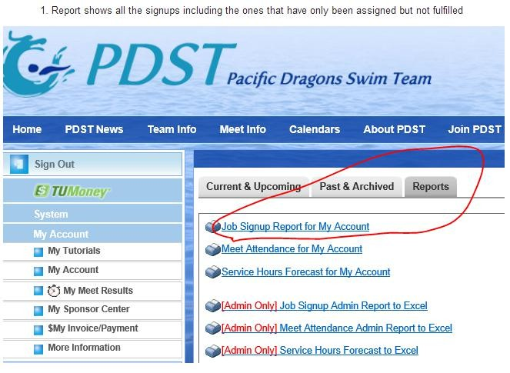
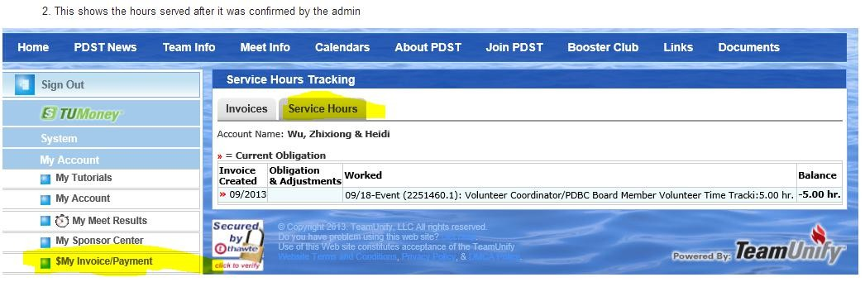

PDBC Funding
- Volunteering hours and employer matching
- Some parent donation
- Funds used for our swimmers, supporting the pools, swimming at large, and team activities

PDST swimmers supported by PDBC

Currently we have 7 parents volunteers serve as board members. The board’s main responsibility is fund-raising, organizing meets hosted by PDST, and organizing volunteer activities, including meets support, travel meet, yearbook and team parties. Thanks to the support from every family and parent like you, we had another successful year. Here are some numbers of 2017-2018:

- Received $17,287 in donations and company matches
- Received $1,120 in volunteer hour donations
- Made $5,575 from hosting the Winter meet
- Spent $2,000 for annual party
- Spent $1,281 for Winter PNS Swimmer Party
- Spent $2,321 for Vancouver Travel Meet
- Spent $5,000 for JCC donation (required to secure pool hours for training)
- Spent $1,500 for Hazen Pool donation (required to secure pool hours for training)
- Spent $3,457 for team relay entry fees
- Total volunteer hours completed: 1376 hours, 10 hours per family in average
- Organized PNS SCY party in Dec 2017
- Organized Regional Champ Swimmer Travel Meet and party in May 2018
- Organized team party in June 2018, more than 200 families attended

PDST Gears @ PDST
- Frequently used swim gears can be purchased at PDST
  - Swim suits, goggles, parka, paddles, special kick board, bungee strap
  - PDST special training gears
  - Go to “Team Info” then “PDST Gear” to order
  - Order is delivered to you at practice, and directly billed into your PDST account

23

PDST Private Lessons

For PDST swimmers only
- Optional, not required
- With Coach’s spare time – limited and will get better
- Sign in “Setmore”. call Leon Li 425-691-9165(11am-7PM, Mon-Fri) or on WeChat if you have any question.

Specific requirement @ each pool

All pools
  - No cell phone use in the locker room
  - No use of the facility by our parents or non-PDST swimmers unless you have the membership at the facility
  - Take a shower before going into the pool
  - Keep noise down – respect other members
- Check-in at JCC front desk is required for non-member PDST swimmers
- We are responsible to follow the rules at each pool (repeated violations can lead to lose our pool contract).
- Team will warn and then bar the swimmer from practice when there are repeated violations by the swimmer.

25

Lessons learned & NOT to be repeated

ü Improvements will ensure PDST to be a better team
ₓ Swimmers
ₓ running around pool deck
ₓ Running with sandals
ₓ played before our practice & hit other patrons at BAC
ₓ yelling/screaming inside the locker room (particularly at SC), not use family-changing area to change/dress
ₓ go into the pool earlier or stay in the pool after PDST practice ends
ₓ used JCC towels while not being a JCC member
ₓ Parents
ₓ parked at the front of the building at JCC
ₓ Wearing shoes at JCC pool deck
ₓ used cell phone in a locker room
ₓ used club equipments while not being a club member
ₓ no time to check emails/website – went to wrong pool/wrong time
ₓ forget swim wears or cap broken (have a set of backup)
ₓ submit meet entry after the deadline
ₓ arrive at the meet a few minutes prior to the event, drop swimmer at the pool

26

An example of Meet Info File

Oct Challenge Meet Info File. Demo: PDST Website

Useful info for you:

Meet name, date, and location
  - Entry info: event #, fees, qualification requirement, order of events
  - From PDST meet entry email: entry deadline
  - PDST website: psych sheet, timeline file and warmup time
  - Online meet entry signup at PDST website

27

PDST History and Achievements

A relatively young team in the PNS of US Swimming

Year | PNS LC Champ Meet (July) | PNS14 & Under SC Champ Meet (Dec.) | NW Age Group SC Sectional Champ Meet (March) | PNS NACC  Team (Aug.) | PNS Western Zone Team (Aug) | Other Highlights
2009 |  | 34th |  |  |  | Sept 1st, First season started with only 29 swimmer
2010 | 15th | 7th |  |  | 3 | January : Booster Club established. April : US Swimming Level 1 Club recognition
2011 | 11th | 5th | 14th | 3 |  | January: 1st PDST swimmer ranked in the National Age Group Top 16
2012 | 5th | 4th | 7th | 4 | 11 | 1st PDST swimmer to break Age Sectional records
2013 | 4th | 5th | 6th | 10 | 2 | PDST swimmers broke Age Sectional 200Y medley relay record.  1st PDST swimmer to break the Western Zone Age Group record in 100M backstroke
2014 | 4th | 5th | 6th | PNS not attending this meet | 8 | First PDST swimmer achieved US Swimming National Junior Times
2015 | 5th | 5th | 6th | PNS not attending this meet | 2 | 7 PDST swimmers ranked National top 200 in their respective age group
2017 | 4th | 5th | 3rd | PNS not attending |  | First PDST swimmer achieved Olympic Trial Times

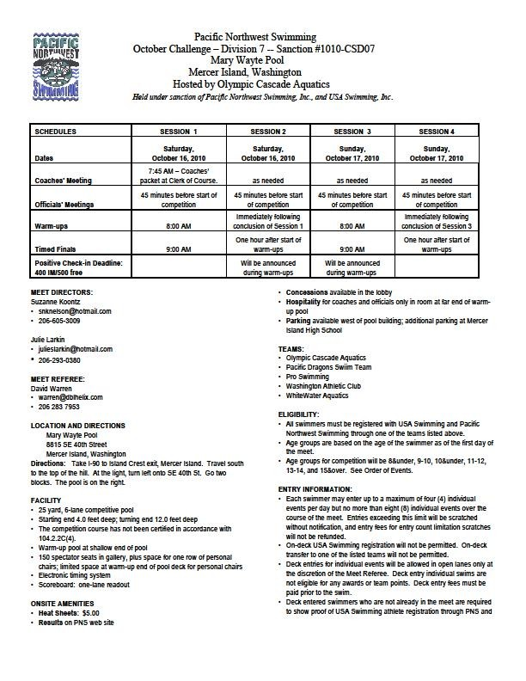

31

PDST Vision/Mission

“Enable all of its swimmers to reach their highest potential as an athlete and as a person through excellence in its coaching, training, and caring.”
- Focus on positive development for our swimmers
- PDST culture: cohesion & a sense of the accomplishment and pride

32

Sign In to your PDST account

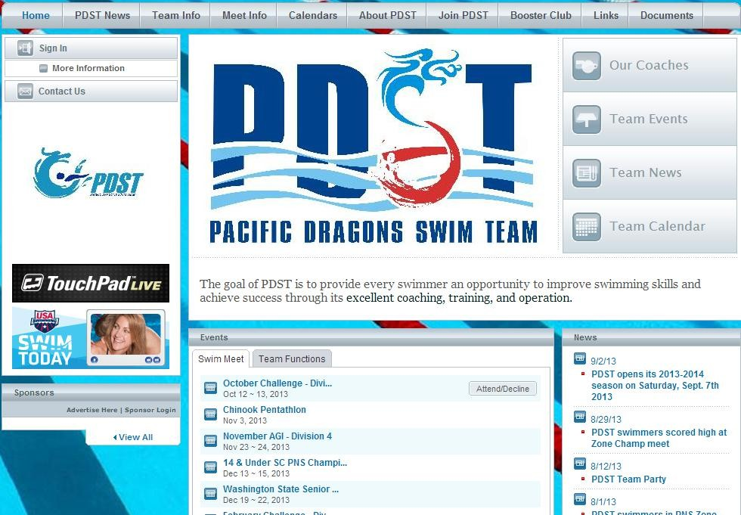Click “Sign In”; sign in your log-in email and the Password which you have received in an email

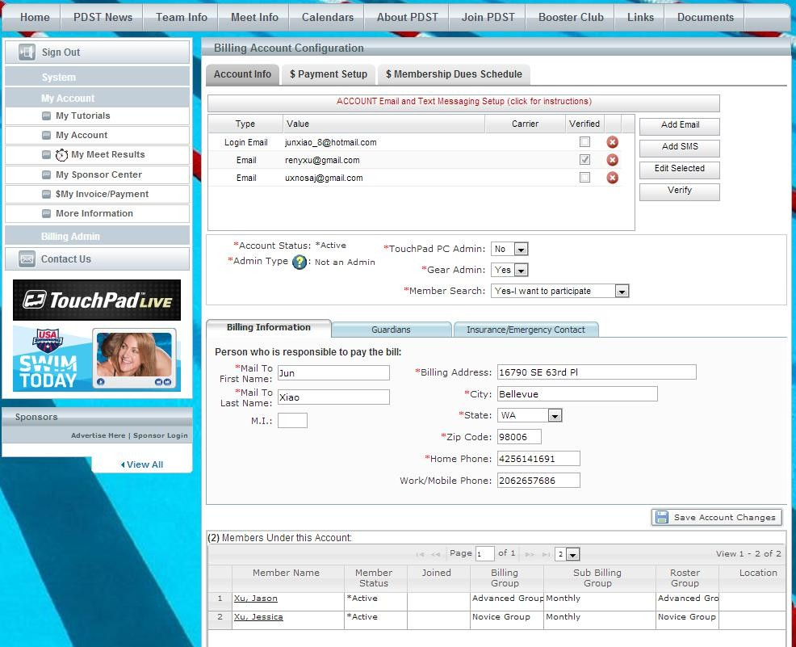Verify Your Account Information Step 1
  - Check your email IDs are correct, if not, highlight the email ID you like to edit, click “edit selected”, then edit it. You can add more email IDor SMS. Email addresses listed will receive team related communications in the future Be sure to click on “Save Account Changes” with any changes

  - Click “Billing Information”; check all information here are correct, if not, correct any errors.
Be sure to click on “Save Account Changes” with any changes

Each family is ONLY allowed 1 log-in email

  - Ensure your swimmer(s) are in the right group assignment. If not, please send an email to pdswimteam@gmail.com to request a correction

Verify Your Account Information Step 2

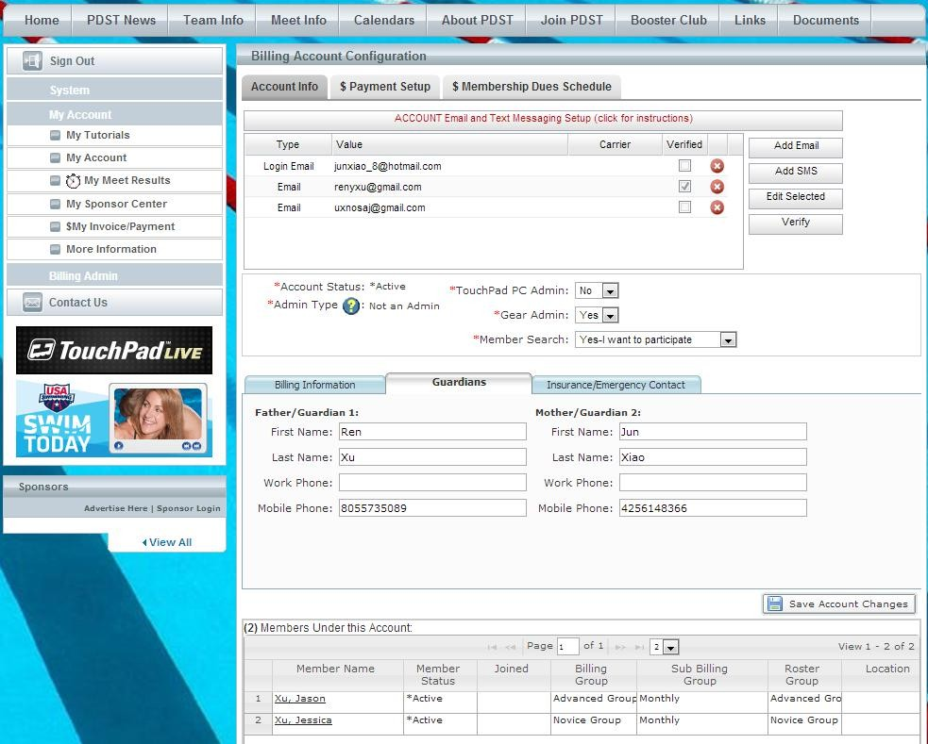Click “Guardian”section; check all information here is correct, if not, correct any errors.
Be sure to click on “Save Account Changes” with any changes

Reset your account password

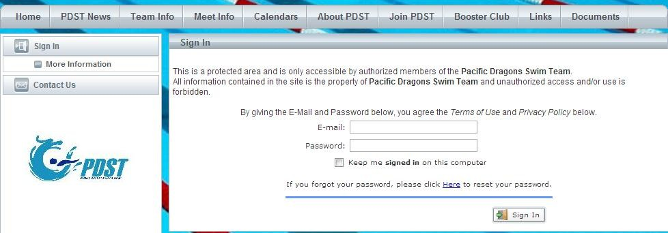
If you need to change or reset your account password, click here and follow the instructions
This is optional.

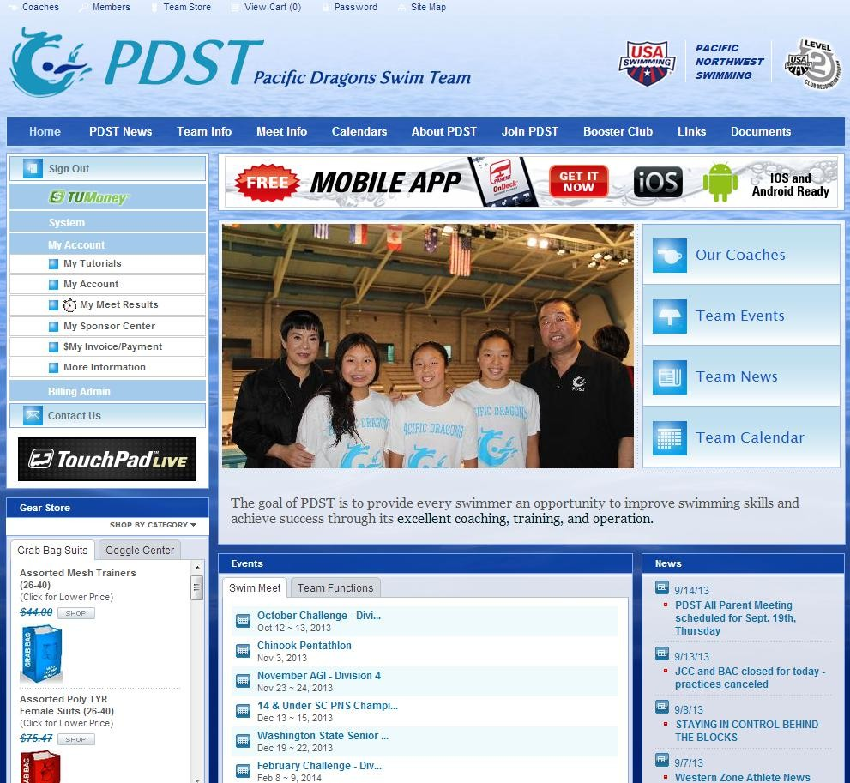Live Demo Section

Always log-into your account to see FULL PDST info

- To manage your family PDST account
- Find other PDST member contact info
- Check practice schedule
- Meet sign up online and find your swimmer’s time
- See your swimmer’s meet fee account
- Volunteer job signup online and see your volunteer hours
- Purchase PDST gears

